**Schema to be Created**

*CREATE TABLE Customers (*

*CustomerID NUMBER PRIMARY KEY,*

*Name VARCHAR2(100),*

*DOB DATE,*

*Balance NUMBER,*

*LastModified DATE*

*);*

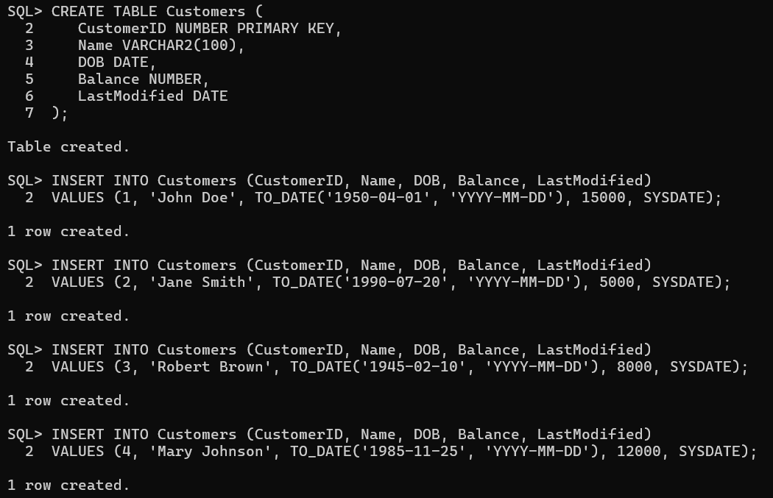

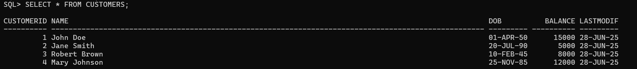

*CREATE TABLE Accounts (*

*AccountID NUMBER PRIMARY KEY,*

*CustomerID NUMBER,*

*AccountType VARCHAR2(20),*

*Balance NUMBER,*

*LastModified DATE,*

*FOREIGN KEY (CustomerID) REFERENCES Customers(CustomerID)*

*);*

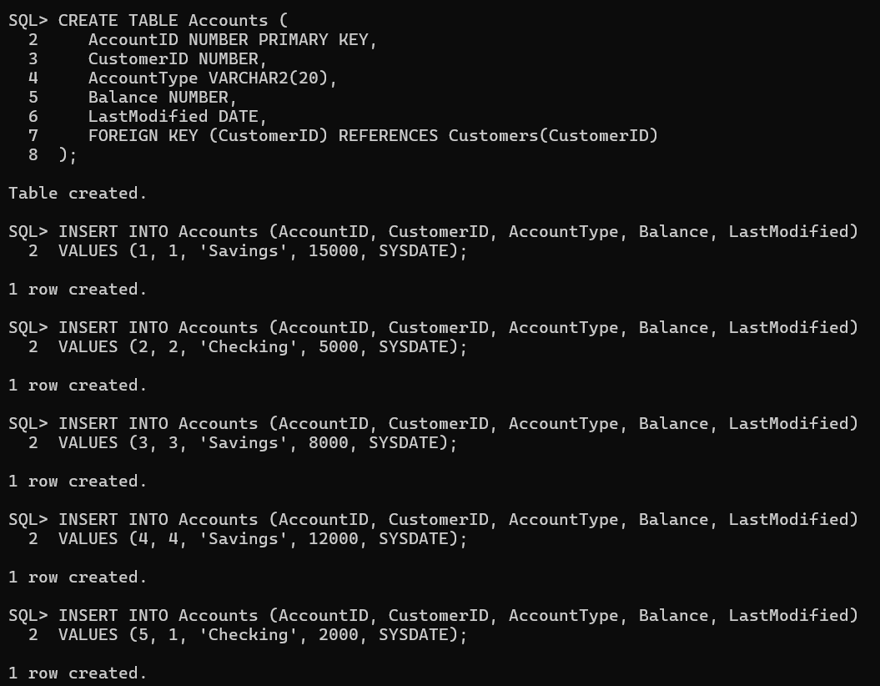

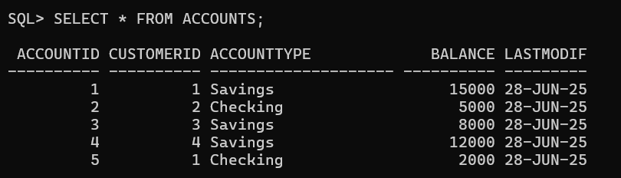

*CREATE TABLE Transactions (*

*TransactionID NUMBER PRIMARY KEY,*

*AccountID NUMBER,*

*TransactionDate DATE,*

*Amount NUMBER,*

*TransactionType VARCHAR2(10),*

*FOREIGN KEY (AccountID) REFERENCES Accounts(AccountID)*

*);*

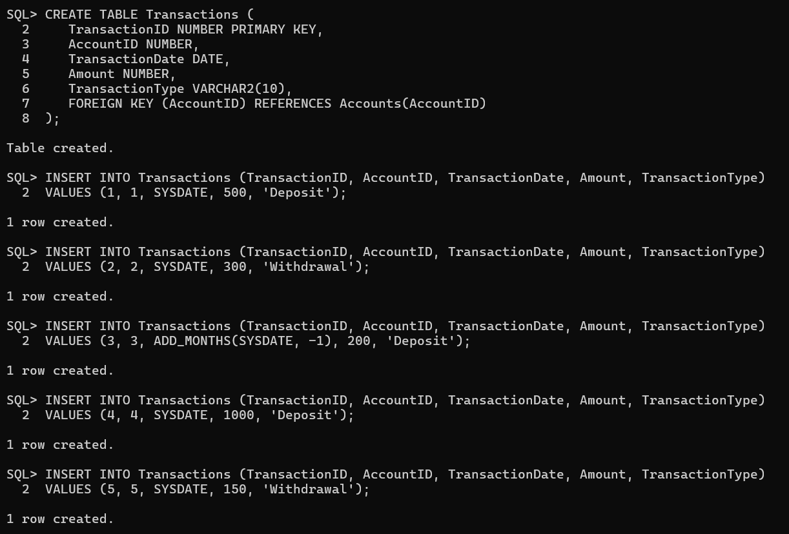

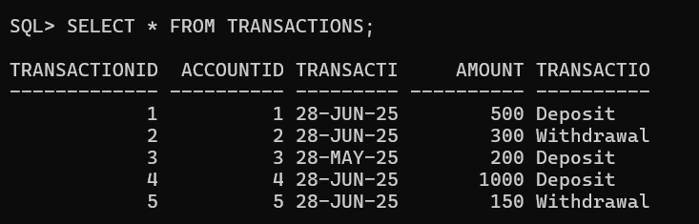

*CREATE TABLE Loans (*

*LoanID NUMBER PRIMARY KEY,*

*CustomerID NUMBER,*

*LoanAmount NUMBER,*

*InterestRate NUMBER,*

*StartDate DATE,*

*EndDate DATE,*

*FOREIGN KEY (CustomerID) REFERENCES Customers(CustomerID)*

*);*

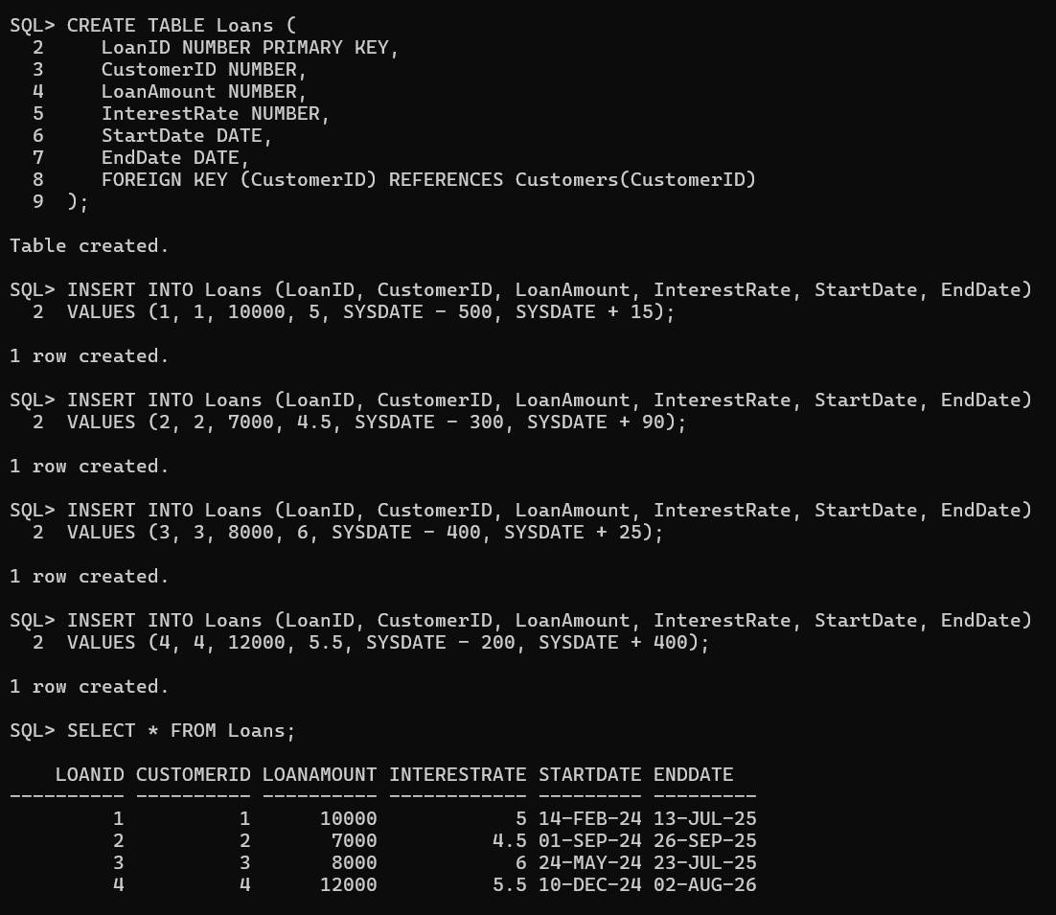

*CREATE TABLE Employees (*

*EmployeeID NUMBER PRIMARY KEY,*

*Name VARCHAR2(100),*

*Position VARCHAR2(50),*

*Salary NUMBER,*

*Department VARCHAR2(50),*

*HireDate DATE*

*);*

